**TITANIUM DIOXIDE**

**HERO**

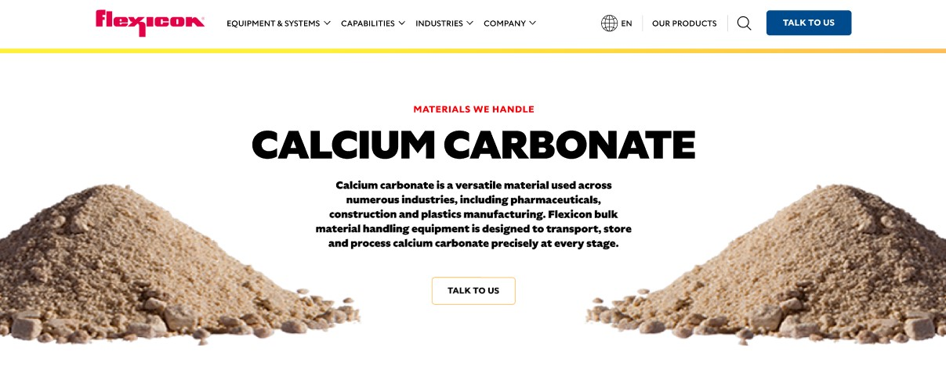

Titanium dioxide is a high-performance pigment used in a wide range of industries, from paints and plastics to cosmetics and construction materials. Flexicon bulk material handling systems are engineered to move titanium dioxide efficiently while minimizing dust, buildup, and product loss.

**Button**: Talk To Us

**SHELF #1 - PRODUCT DESCRIPTION**

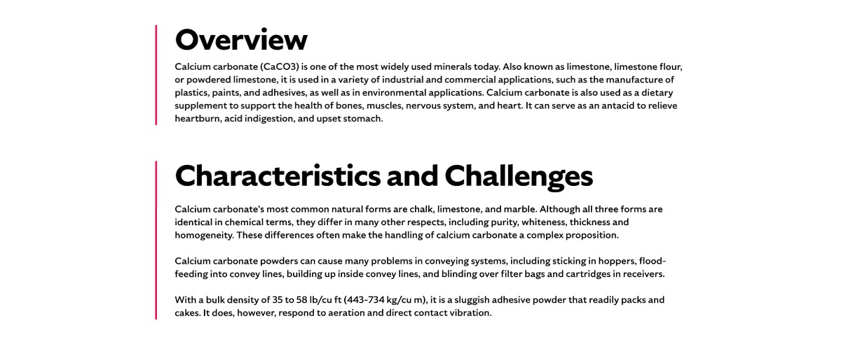

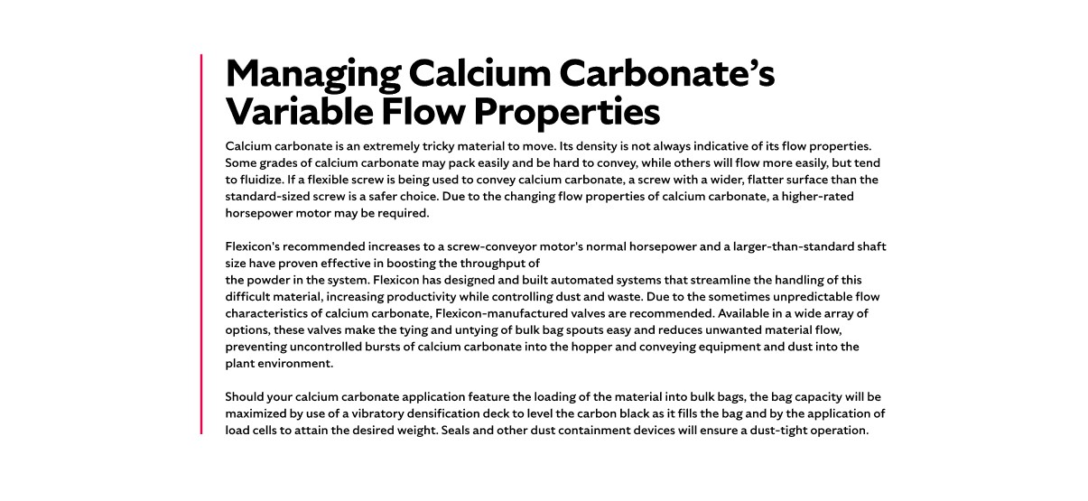

**Overview**

Titanium dioxide (TiO₂), also known as titanium IV oxide or titania, is one of the whitest and most reflective substances known. It is widely used to enhance brightness and opacity in products such as paints, coatings, plastics, inks, and cosmetics. Its refractory nature also makes it valuable in protective coatings and optical applications. As one of the most-produced industrial chemicals globally, titanium dioxide plays a vital role in manufacturing and product performance across sectors.

**Characteristics and Challenges**Titanium dioxide is an odorless, white powder known for its cohesive, adhesive, and non-free-flowing nature. It tends to cake, pack, and smear, making it difficult to handle and prone to forming deposits in conveying systems. It is moderately abrasive and can coat steel surfaces. Titanium dioxide is incompatible with strong oxidizers, acids, and certain reactive metals, which may lead to hazardous reactions. Prolonged exposure should be avoided, as inhalation of dust can cause respiratory issues and skin dryness. There is also some evidence suggesting it may be carcinogenic. Safe storage requires a clean, dry environment away from heat, flames, and strong-smelling chemicals.

Due to its poor flow characteristics, titanium dioxide can bridge or rat-hole in hoppers, potentially causing blockages and shutdowns. Specialized equipment such as spring-loaded bulk bag frames, bag activators, dust collectors, and pneumatic pulse filters are recommended to improve flow and minimize operator exposure. When unloading from smaller bags, a bag-breaking station with dust control features is ideal. For conveying, screws with wider, flatter surfaces are more effective. During bulk bag filling, vibratory densification decks and load cells help optimize capacity and maintain a dust-tight process. Proper design and dust containment are essential to ensure safe and efficient handling.

**SHELF #2 - FLEXICON SOLUTIONS**

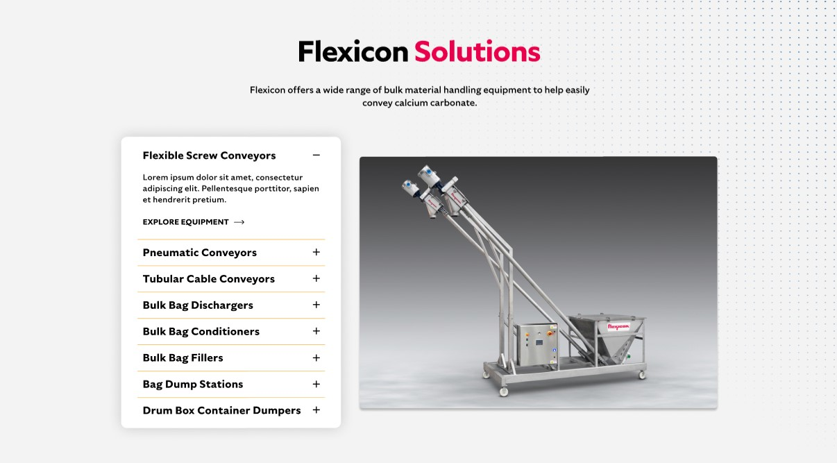

**Flexicon Solutions**

Flexicon offers a wide range of bulk material handling equipment to help easily convey calcium carbonate.

* **Flexible Screw Conveyors:** Designed to gently move titanium dioxide while reducing the risk of material compaction, smearing, or accumulation within the screw or conveying tube.
* **Pneumatic Conveyors:** These fully enclosed systems use integrated filtration to capture and return airborne titanium dioxide dust to the hopper, ensuring a clean and efficient transfer process.
* **Tubular Cable Conveyors:** Ideal for cohesive powders like titanium dioxide, these enclosed systems offer gentle, low-impact conveying—especially useful in facilities with limited space.
* **Bulk Bag Dischargers:** Provide a sealed, dust-controlled method for unloading titanium dioxide from bulk bags, often equipped with flow-assist features to improve discharge efficiency.
* **Bulk Bag Conditioners:** Break up compacted titanium dioxide within bulk bags, helping to restore flowability and ensure consistent material discharge during processing.
* **Bulk Bag Fillers:** Accurately fill bulk bags with titanium dioxide using vibration decks for even distribution and sealing systems to minimize dust emissions.
* **Bag Dump Stations:** Enable safe, manual emptying of titanium dioxide from smaller bags, with built-in dust hoods and filtration to protect workers and maintain air quality.
* **Drum and Box Dumpers:** Facilitate the controlled transfer of titanium dioxide from smaller containers into processing lines, reducing manual handling and limiting dust exposure.

**SHELF #3: LIFETIME PERFORMANCE GUARANTEE**

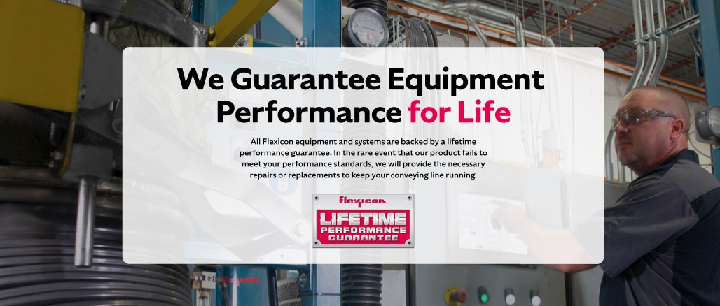

**Lifetime Performance Guarantee**

All Flexicon equipment and systems are backed by a lifetime performance guarantee. In the rare event that our product fails to meet your performance standards, we will provide the necessary repairs or replacements to keep your conveying line running.

**SHELF #4: CASE STUDIES**

